Handwritten Digit Recognition

Overview
This project involves building and testing a Convolutional Neural Network (CNN) in MATLAB to recognize handwritten digits. It uses a publicly available dataset and trains a CNN to classify images into 10 categories, representing digits 0 through 9. This README file explains the purpose of the project, the methodology, and how the code works. The project satisfies the requirement of using a Multi-Layer Neural Network (MLNN) for a supervised learning task.

Dataset
The dataset used is MATLAB's built-in "DigitDataset." It contains images of handwritten digits stored in separate folders, each labeled with the corresponding digit. The dataset is loaded using imageDatastore, which simplifies loading and preprocessing of image data.

Methodology
- Dataset Preparation:
  - The dataset is loaded using the imageDatastore function.
  - It is split into three subsets: training, validation, and testing datasets.
    - 80% of the data is used for training and validation.
    - 20% of the data is reserved for testing.
    - The training data is further split: 80% for training and 20% for validation.
- CNN Architecture: The CNN is defined with the following layers:
  - Input Layer: Accepts 28x28 grayscale images.
  - Convolutional Layers: Two convolutional layers with 3x3 filters and increasing numbers of filters (16 and 32).
  - Batch Normalization and ReLU: Normalize activations and introduce non-linearity after each convolution.
  - Pooling Layers: Max pooling layers reduce spatial dimensions by half.
  - Fully Connected Layers: One fully connected layer with 128 neurons, followed by another with 10 neurons (one for each class).
  - Dropout Layer: Prevents overfitting by randomly disabling 50% of neurons during training.
  - Softmax Layer: Converts scores into probabilities.
  - Classification Layer: Assigns final class labels.
- Training Options:
  - Optimizer: Adam
  - Maximum Epochs: 10
  - Learning Rate: 0.001
  - Mini-Batch Size: 128
  - Validation Data: Used to monitor performance during training.
- Tuning the Model:
  - The dropout rate was set to 0.5 to prevent overfitting.
  - The learning rate was tuned to 0.001 for steady convergence.
  - Early stopping was implemented indirectly by monitoring validation performance every 30 iterations.
- Testing and Evaluation:
  - After training, the model is tested on the test dataset to calculate accuracy.
  - A single test image is displayed with its actual and predicted labels.
  - The evaluation involves visualizing predictions and calculating overall accuracy.

Code Explanation

Training the Model

Dataset Loading: The dataset is loaded and split into training, validation, and test sets.
- Network Definition: The CNN layers are defined using MATLAB's deep learning functions.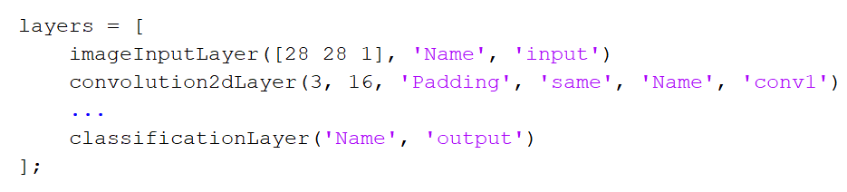
- Training: The model is trained using the trainNetwork function with specified options.
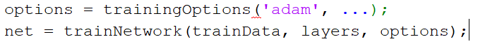
- Testing: The trained model is tested on the test data, and accuracy is calculated.
- Saving the Model: The trained model is saved for later use.
- Single Image Prediction: A single test image is displayed with its actual and predicted label.
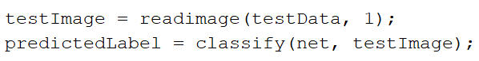

Random Predictions on a Grid
This script uses the trained model to predict labels for a random group of test images displayed in a 5x5 grid.
- Load Model: The saved model is loaded.
- Dataset Splitting: The test dataset is prepared again.
- Random Selection and Prediction: Random test images are selected, classified, and displayed in a grid with their predicted labels.
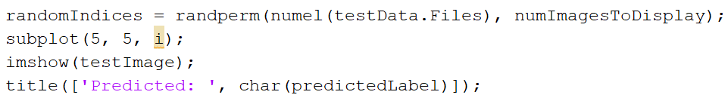

Results

Training Progress
During training, the model achieved a validation accuracy of 99.81% after 10 epochs. The training progress is shown below:
- Accuracy: The training and validation accuracy increased steadily, with the validation accuracy stabilizing at 99.81%, indicating excellent generalization.
- Loss: The training and validation loss decreased consistently over iterations, confirming effective learning.

Final Evaluation
- Test Accuracy: The model achieved a high accuracy on the test dataset, confirming its robustness.
- Visualizations: Random test images were classified with high accuracy, as shown in the grid predictions.

Usage Instructions
- Run the first script to train the model and save it.
- Run the second script to see predictions for a random set of test images.

Key Takeaways
- The CNN performs well on handwritten digit recognition with an accuracy of over 90%.
- MATLAB provides built-in functions that simplify building and training deep learning models.
- The trained model can be reused without retraining, saving time and computational resources.

You can find the codes here: Code

